**DAILY ONLINE ACTIVITIES SUMMARY**

|  |  |  |  |  |  |  |  |  |
| --- | --- | --- | --- | --- | --- | --- | --- | --- |
| **Date:** | **28/05/2020** | | | | | **Name:** | **Varshitha V Makam** | |
| **Sem & Sec** | **8th B** | | | | | **USN:** | **4AL16CS118** | |
| **Online Test Summary** | | | | | | | | |
| **Subject** | | **SMS** | | | | | | |
| **Max. Marks** | | **60** | | **Score** | | | **57** | |
| **Certification Course Summary** | | | | | | | | |
| **Course** | Introduction to Hadoop | | | | | | | |
| **Certificate Provider** | | | **Great learning** | | **Duration** | | | **4 hours** |
| **Coding Challenges** | | | | | | | | |
| **Problem Statement:** | | | | | | | | |
| **Status: COMPLETED** | | | | | | | | |
| **Uploaded the report in Github** | | | | | **YES** | | | |
| **If yes Repository name** | | | | | **varshithamakam https://github.com/alvas-education-foundation/varshithamakam** | | | |
| **Uploaded the report in slack** | | | | | **YES** | | | |

Online Test Details:

Test on module 1

Snapshot of test

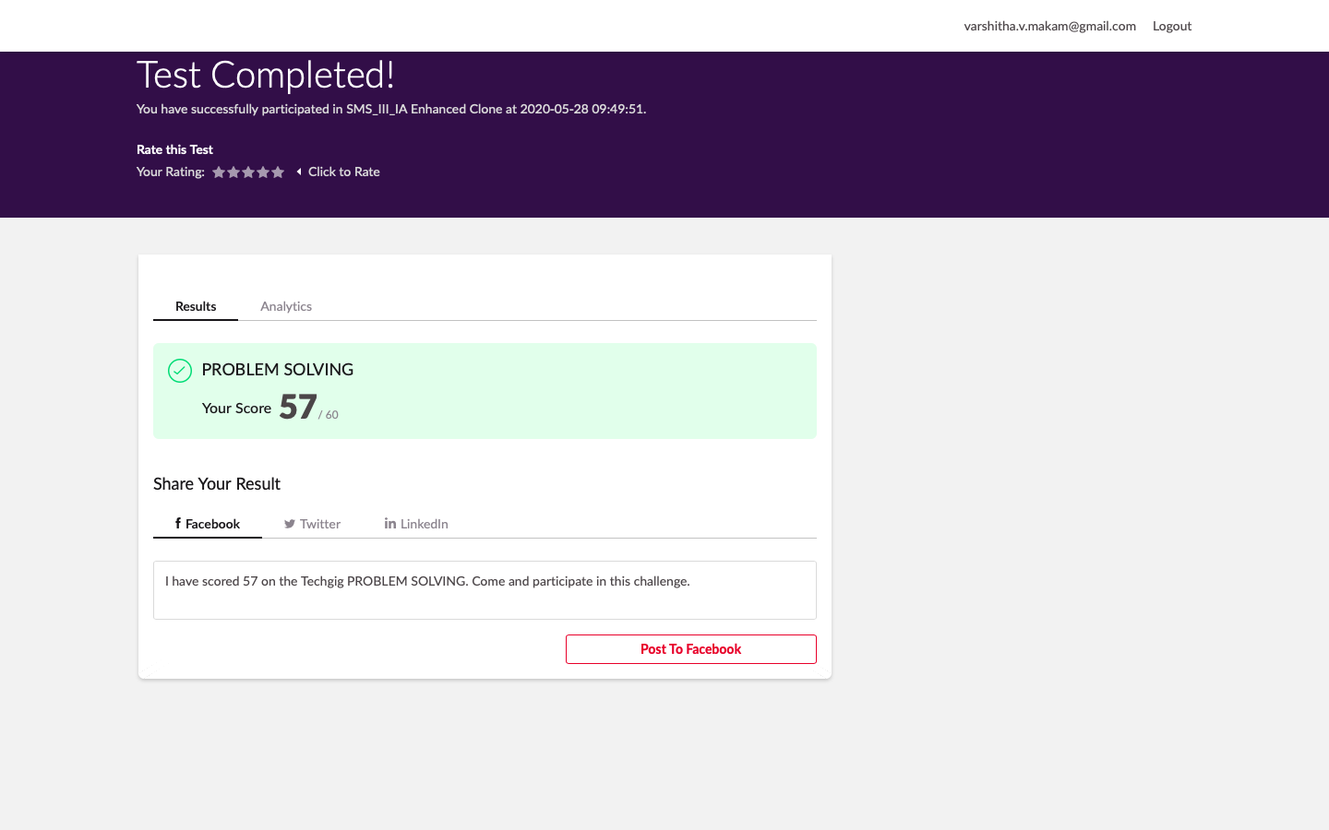

Certification Course Details:

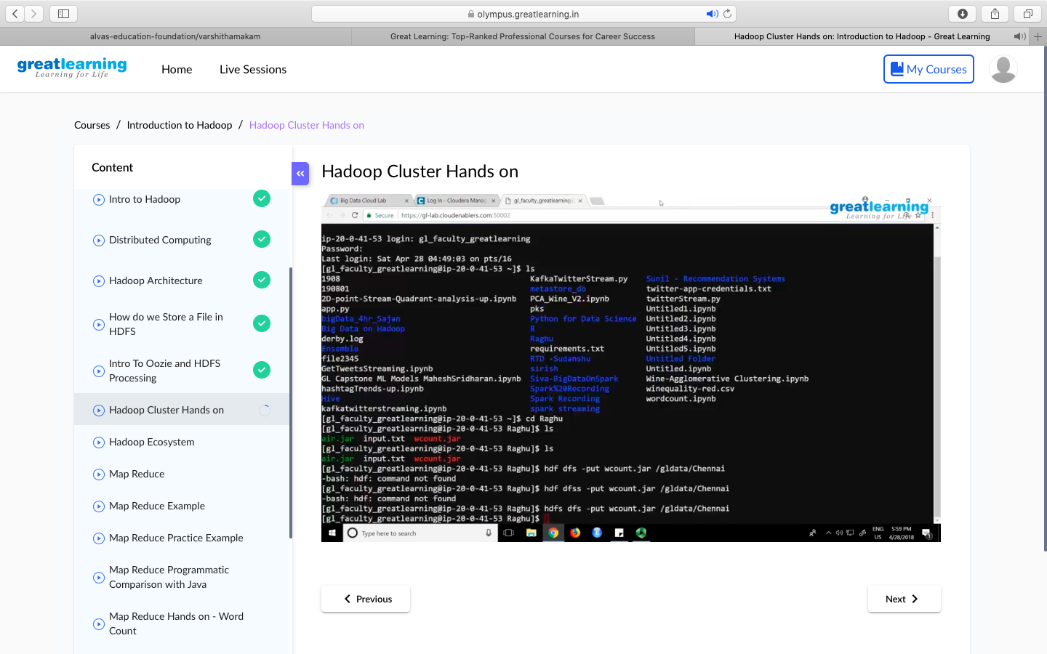

Coding Challenges Details

**Program no:1**

Write a C program to print all permutations of a given string using pointers.  
#include <stdio.h>  
#include <string.h>  
void swap (char *x, char *y)  
{  
char temp;  
temp = *x;  
*x = *y;  
*y = temp;  
}  
void permute(char *a, int i, int n)  
{  
int j;  
if (i == n)  
printf("%s\n", a);  
else {  
for (j = i; j <= n; j++)  
{  
swap((a + i), (a + j));  
permute(a, i + 1, n);  
swap((a + i), (a + j));  
}  
}  
}  
int main()  
{  
char a[20];  
int n;  
printf("Enter a string: ");  
scanf("%s", a);  
n = strlen(a);  
printf("Permutaions:\n");  
permute(a, 0, n - 1);  
getchar() ;  
return 0;  
}